The Text on the Wet Sweaty Window
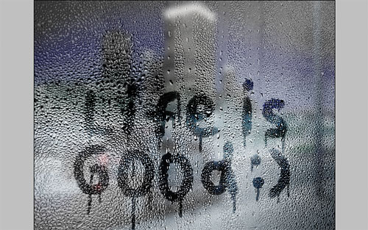
Would you like how to create the text on the wet sweaty window in Photoshop? If yes, so, this tutorial special for you!
Download Text on We Window from my website
Open up the picture and apply Image > Adjustments > Desaturate to make it black and white.
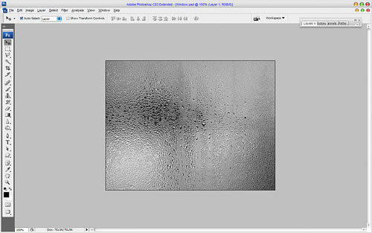
After that I would like to reduce brightness with Image > Adjustments > Levels using following presets:
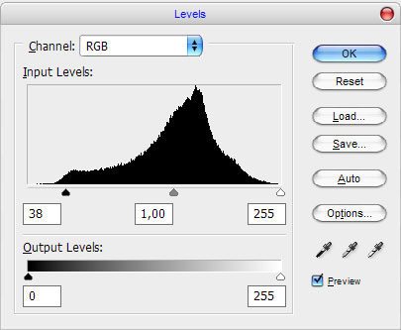
Your result should look as mine:
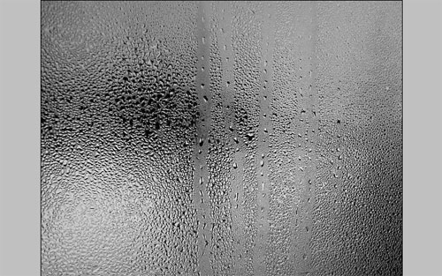
Ok, after that I would like to add one more picture, for example, night city picture as the street background out of glass. Open car in the city from my website. Bring it to our canvas and reduce with Edit > Free Transform as shown on my picture below:
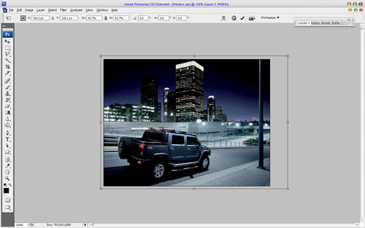
To bring it realistic view apply Filter > Blur > Gaussian Blur with similar settings to these:
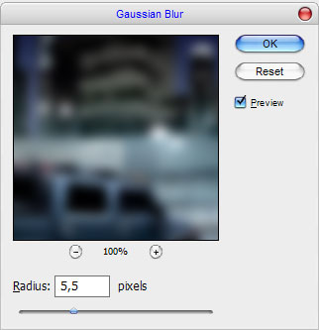
Change layer mode to Overlay and set opacity up to 80%. See what we have now:
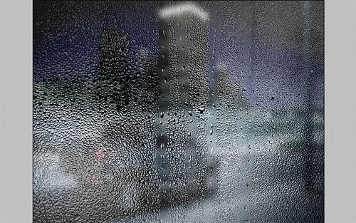
Ok, move to the main strep of our tutorial. Select the Brush Tool and chose the one brush from the standard Photoshop brushes gallery:
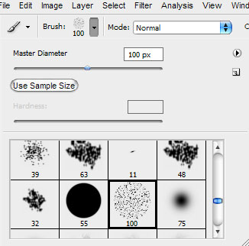
After that reduce brush size till 30 pixels and draw out the text with black color on the new layer.
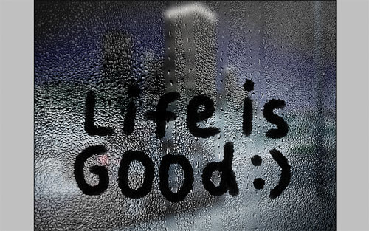
Reduce brush size till 8 pixels more and add small burr in some places.
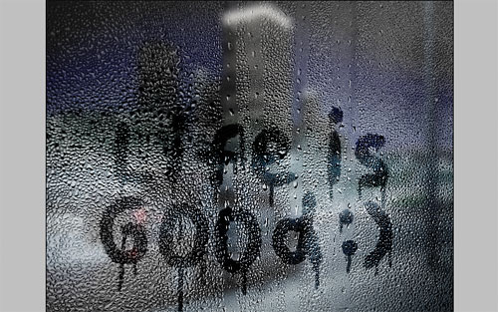
To emphasize the focus on the text create a new one layer and fill it with white color. After that mess with the layer mode & opacity/fill. I tried Soft Light with a fill of 67%.

