Final Image Preview
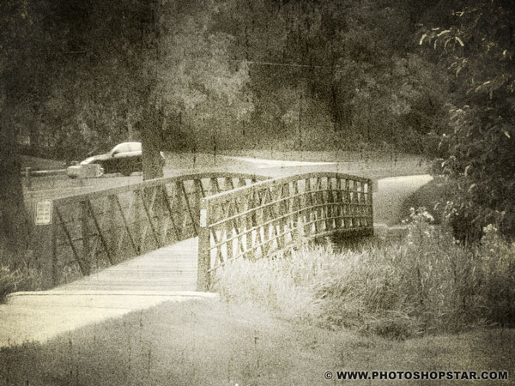

Resources
- Small Bridge

Step 1
Start by opening photo. Go to Image > Image size to reduce photo size to 1000px width and 750px height.

Step 2
We are going now to create noise effect. Create new layer, press D to set up foreground and background colors as black and white and then apply Filter > Render > Clouds.
Step 3:
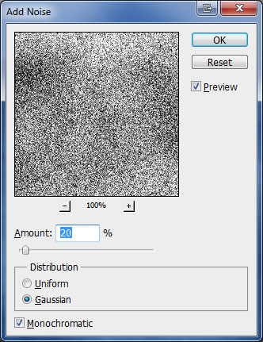
After that apply Filter > Noise > Add Noise with next presets:

Step 4
Change layer mode to Soft Light for this layer.
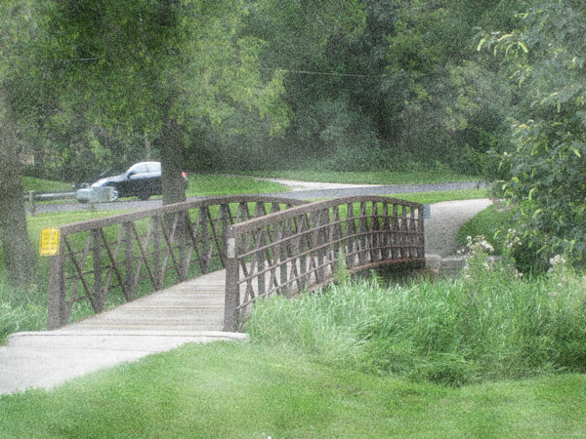

Step 5
Now we are going to create light sepia effect. For this purpose I created new layer above and fill it with color of #e6e1cc.

Step 6
Then change layer mode to Color and you should get next effect.
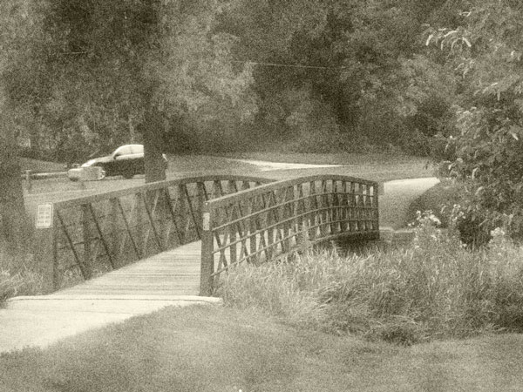

Step 7
After that create additional layer with Layer > New Adjustment Layer > Levels:
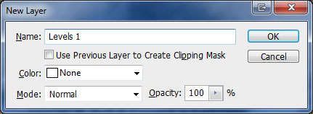
And set up following levels presets:
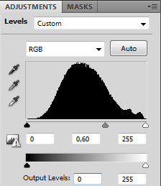
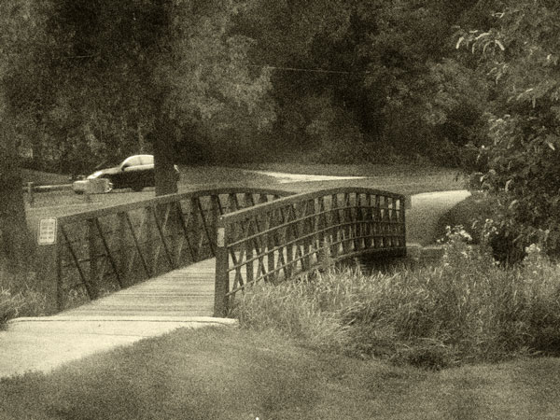

Step 8
To add scratches to the photo create new layer, press D to set up foreground and background colors as black and white and then apply Filter > Render > Clouds again.

Step 9 Apply Filter > Render > Fibers: 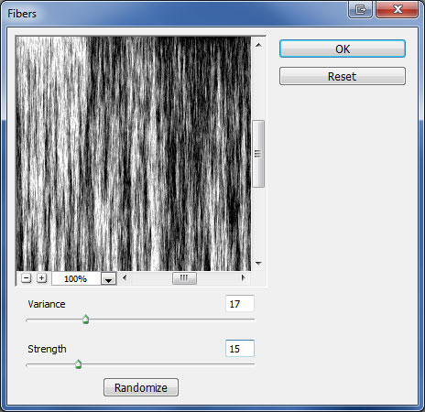

Step 10
Now apply Image > Adjustments > Threshold:
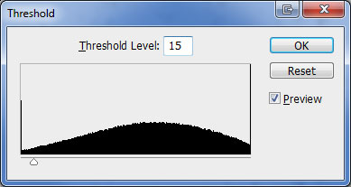

Step 11
Now apply Image > Adjustments > Threshold:
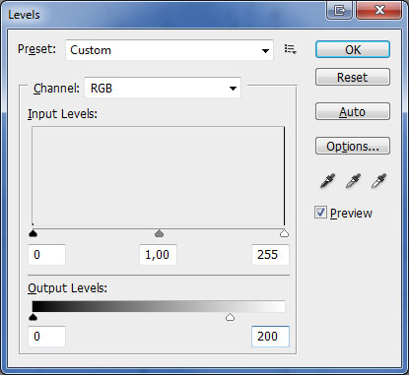

Step 12
Apply again Filter > Blur > Blur More.

Step 13
Change layer mode to Soft Light and you will see the difference.
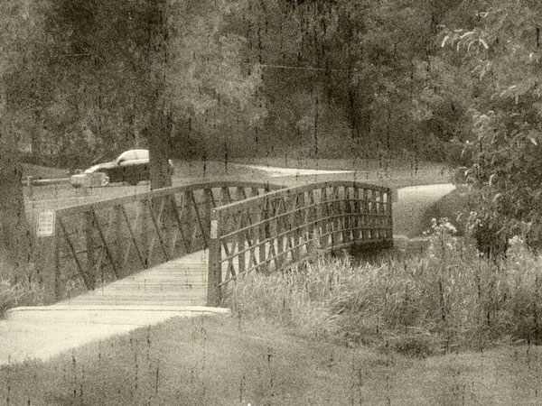

Step 14
Reduce layer opacity to 70%.
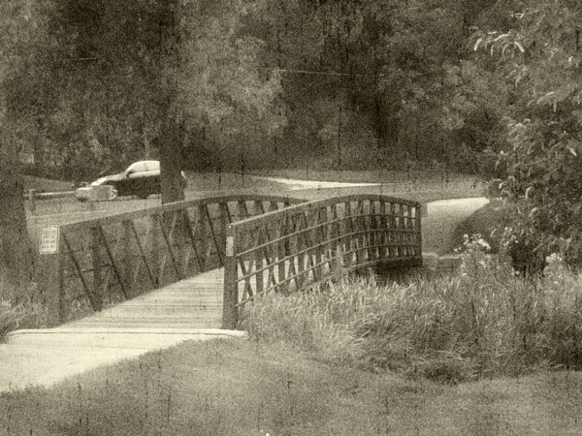

Step 15
Create a new layer. Select Gradient Tool, select some appropriate colors, for example colors of #e5e5e5, #000000 and drag a radial gradient.

Final Image
After that change layer mode for this layer to Overlay and tutorial is complete.

