NCAA MARCH MADNESS ACTIVITY Redesign the Logo—Photoshop Logos from http://www.sportslogos.net

For this project, you are to recreate one of the logos below, but make it NEW and IMPROVED. You may not use any images from the internet for the text of the project (the year, Final Four, and location) and you may not use any “combined” graphics files. You may use single high quality objects, user‐created shapes (using selection/pen tool), special brushes, etc. See requirements below and scoring guide for more details. Alternatively, if you’d like to create a new location for the Final Four, you may do that. Use the year 2020 for that logo.

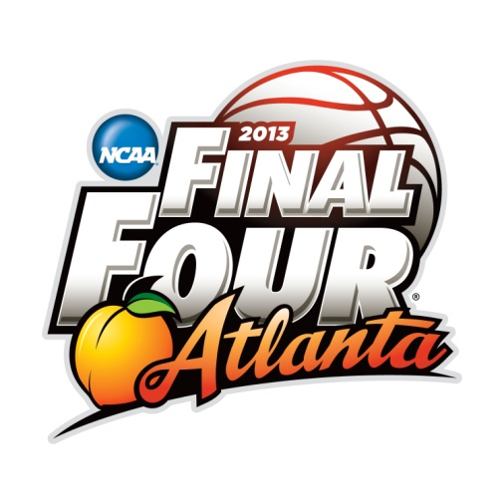

Review the examples of logos above. Notice some features common to many of the final four logos that you will incorporate into your redesign:
- Use of a large sans serif font for the words Final Four
- Use of an image that represents that state and a basketball (used in the bottom three examples)
- Use of text in a special shape (arc, banner wave, or vertical text)

• Use of thick stroke and/or glow around Final Four type
NCAA MARCH MADNESS ACTIVITY Redesign the Logo—Photoshop Scoring Guide
This project requires advanced planning. You must sketch out your design before you begin. Fonts, brushes, and clipart images should be selected before you begin the actual process of assembling the logo. Create a folder called logo and put all the needed files in it.
Clipart selected/saved as: ______________________________ Font for year:________________________ Font for Final Four: __________________ Font for city: __________________ Special Brushes: ________________________________ Shapes: _______________________
Sketch out the proposed logo at right. Note any thicker strokes, transparency, masks, layer effects, colors, etc. Label everything required on the scoring guide!
Setup: width set to 7 inches, height to 5 inches, resolution of 150 pixels/inch, color mode—RGB Color, Background to white | 10
sketch, fonts, and overall plan | 10
Large sans serif font for the words Final Four that includes use of thick stroke and/or glow and/or other layer styles  􀀣 List what you used for full credit: | 10
Use of special brushes and/or shapes  􀀣 List what you used for full credit: | 5
Includes required type—year, Final Four, and city of the tournament | 5
NCAA logo is used intact and to scale (either in the shape or just the letters) | 5
Minimum of two clipart items—something to represent the city and a basketball | 5
Quality of clipart | 5
Type is transformed in some way—use of warp, skew, or vertical type | 5
File printed in color portrait orientation at 100% size (do not scale) | 5
TOTAL | 65

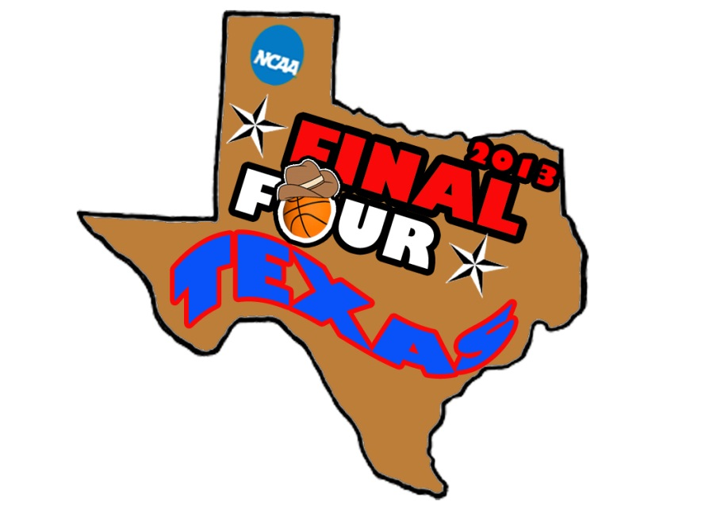
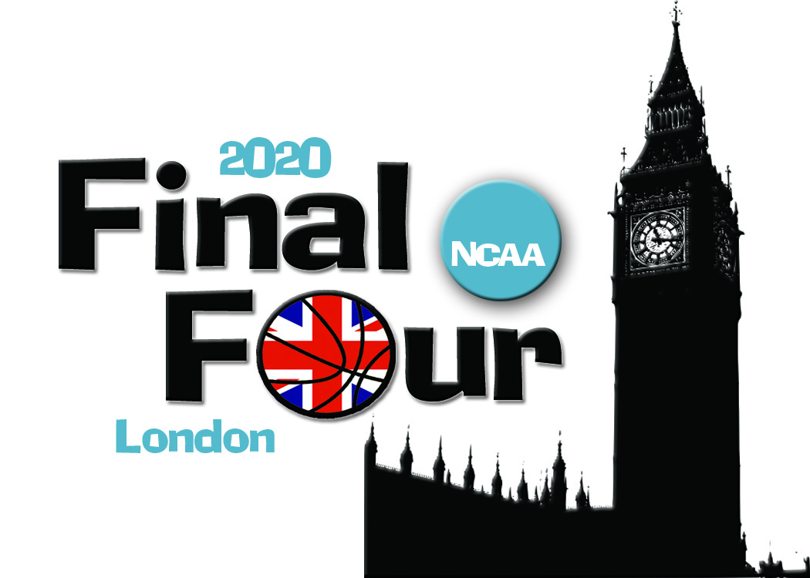
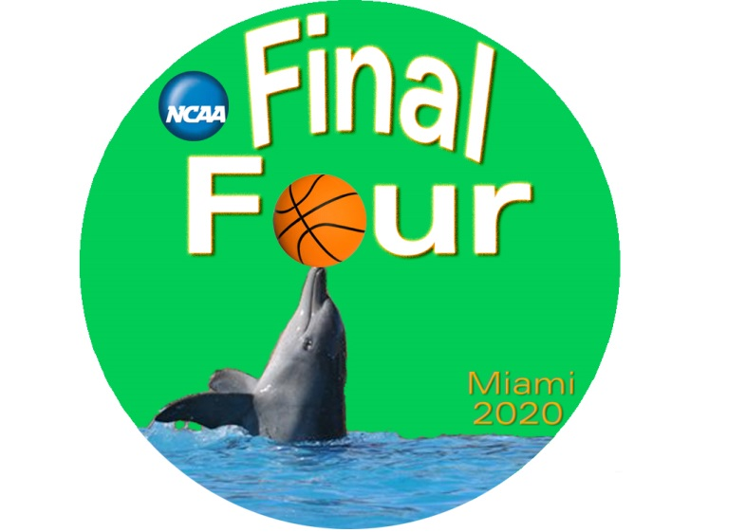
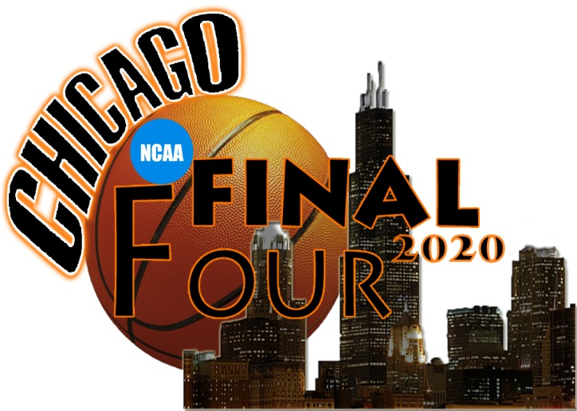
Examples:

